|  |  |
| --- | --- |
|  | Virtual Machine Configuration |
|  |  |
|  | James Duncan  Computer Systems, Infrastructure & Management  [Date] |

Contents

Virtual Machine Beginning State 2

Admins 3

Securing root user 4

User accounts 5

Configuring SSH & Public Key Authentication 5

Known Host Authentication 7

User Groups and Folder permissions 7

Uploading Research Material 9

Critical Reflection & Conclusion 9

Bibliography 10

Appendix 11

Annika Tests 11

Steve Tests 11

Laura Lance Tests 12

John Tests 12

# Virtual Machine Beginning State

The Virtual Machine (VM) first starts as a fresh install of Arch Linux with none of the settings required for this project. The first thing the admin has to do is to change the hostname of the virtual machine to be consistent with the admins student ID (in this case “student-555426), this is part of establishing an internet connection for the Virtual machine which is required for network connectivity used later in remote access using SSH (Secure Shell). This can be achieved by changing directory to the “etc folder” with the “cd” command and finding the file called “hostname”. The admin can navigate and find files by using the “ls” command that shows the contents of the directory. By standard the only text editor on the machine is vim so vim must be used to edit the hostname file, once edited the admin can save and exit the file by pressing escape and providing the “:wq” command. Confirmation of writing the hostname can be found in figure 1.



*Figure 1: Hostname written*

The VM can then be rebooted and connection to the internet can be tested by pinging an IP address (Google DNS 8.8.8.8), your own IP address can also be found by issuing the command “ip addr” which will print all the network connectivity information which can be found in figure 2. In this case the IP address for this VM is 150.237.92.31 as found in section 2 of figure 2.

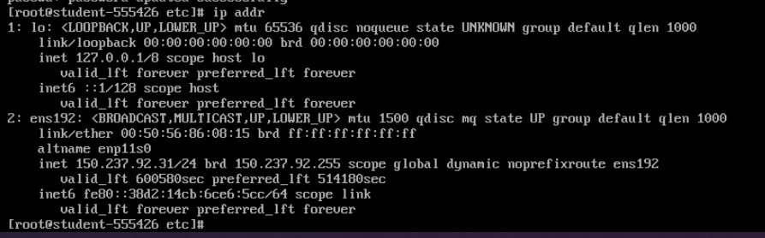

*Figure 2: Network Information*

Once a connection has been established the admin can check if all the packages from the Arch Linux Distribution are up to date with “pacman -Syy” which checks all the packages that the install has and what it depends on checking if they are up to date or not. This can be shown in figure 3.

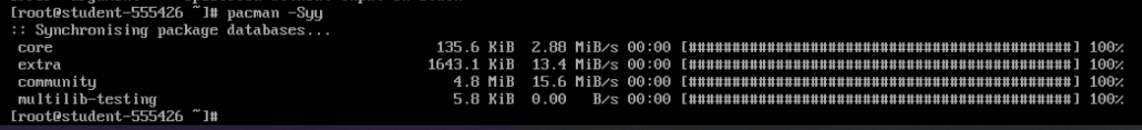

*Figure 3: Updating Arch Linux Package*

Other installs can be done with pacman as well such as installing a new more convenient text editor, so the admin does not have to use vim. Nano (text editor) can be installed by using “pacman -Sy nano” to synchronise and fetch the latest copy of the editor. The manual pages can also be installed so that the user can use “man nano” to get a help sheet of all the provided commands nano offers.

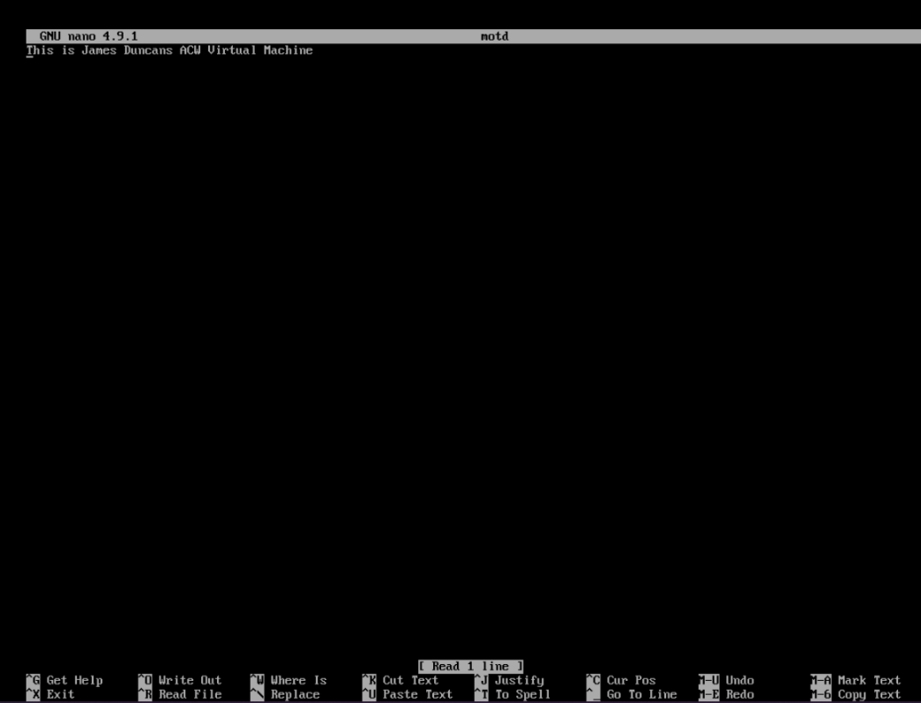Nano can now be tested by changing the “motd” file in the “etc” folder, this is the message that shows up when the VM is successfully logged into. You can find the nano example in figure 4.

*Figure 4: Nano motd*

# Admins

Part of securely locking down a virtual machine is to create admins that have access to run high level commands that a normal user may not have access to. Their prime use is to keep the system functional for the users it supports. To create an admin account the “useradd -m <username>” command can be supplied which will add a user with a home directory (-m) of whatever user name supplied. For this system both James Duncan and Ashley Williamson will require an admin account so both accounts should be created. This is shown in Figure 5.



*Figure 5: Create admin accounts*

These accounts require SUDO access to perform root level commands or bypass permissions, as a result sudo must be installed on the virtual machine, this can be achieved by using “pacman -Sy sudo” which installs the sudo packages. Once Sudo is installed it is possible to give the accounts sudo access through the sudoers file, this file contains all the configurations for sudo users, however to access this it is required to set an editor to edit the file, this can be done by running the “export EDITOR=nano” which sets the default text editor. The user can then run the visudo command and it will open the sudoers file in the nano text editor set using the export command. Once access to the sudoers file has been established there are two ways of granting the users sudo access, first you can directly state the user in the sudoers file as shown in figure 6, where the user is declared, and they are given access to sudo without inputting a password.

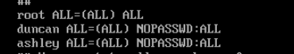

Figure 6: Add users to Sudoers file

Alternatively, you can enable the “wheel” group to grant sudo access and add both admins to the wheel group. Using the wheel group is preferred as if you want a new admin you can just add this account to the wheel group which directly grants sudo access instead of having to change the sudoers file consistently, this is shown in figure 7.

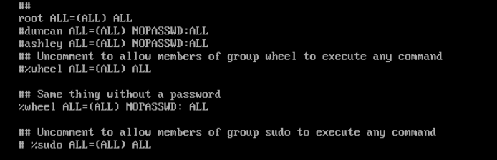

*Figure 7: Wheel Group Sudo*

These users must now be added to the wheel group in order to use the sudo permissions that wheel has, this can be done by using “usermod <username> -g wheel” this will add the user to the group (-g) wheel. This is shown in figure 8.

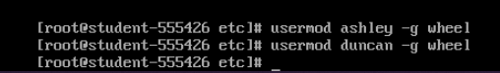

*Figure 8: Add Admins to Wheel Group*

These user now have sudo access which makes them incredibly powerful users in the system, these accounts should be the most secure accounts on the network so their passwords should be changed to a secure password. A secure password should not be obvious to any user and should be complicated enough to not be brute forced, therefore a secure password can be made by a user although the user should abide by the Hull University Password Policy (Hull University , 2020). For these passwords the admin chose to use the website random key gen to generate passwords for these accounts (Random Keygen, n.d.). To change these passwords the root user can issue the command “passwd <username>” as the root user and sudo users can change anyone’s passwords but normal users can only change their own. This is shown in Figure 9.

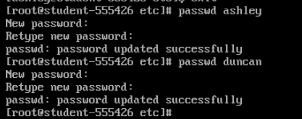

*Figure 9: Change Admin Passwords*

*Duncan: LMvsGplYwW , Ashley: UyQ3xNJTZA*

# Securing root user

Now that the system has admin accounts that can manage and administrate the root account is no longer required and should be locked down as much as possible as if someone has access to this account they could cause significant damage to the system. The root password can be changed as above this ensures some security although its best that root is entirely disabled so no user can login as root. This is possible by navigating to “etc” and editing the “passwd” file with nano, the admin can now change the root user to have no logins from users, this is shown in figure 10. Once saved no user can log in to root which is shown in figure 11.

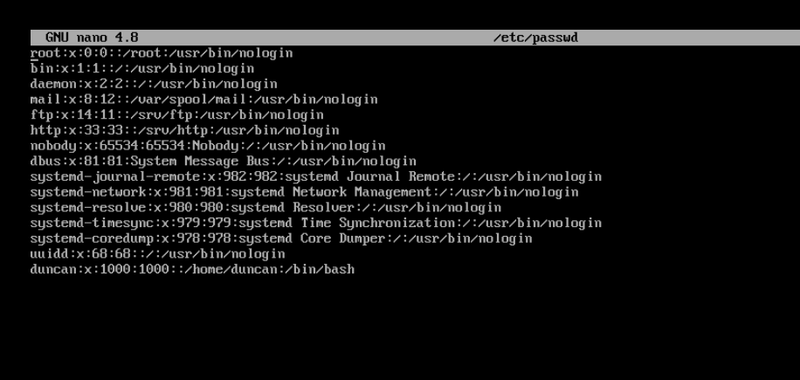

*Figure 10: disable Root Access*

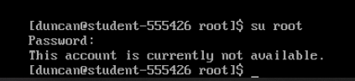

*Figure 11: Root Disabled*

# User accounts

Now that root is secured and there are admin accounts we can create our users for the system, the same useradd command can be run for these accounts as shown in figure 14. The passwords for these users should be set, however, they are less important than the admins as they don’t have sudo access. The admin can set these passwords to the users first name although, when the user first logs in they should change their own password to be in compliance with Hull University’s guidelines (Hull University , 2020)

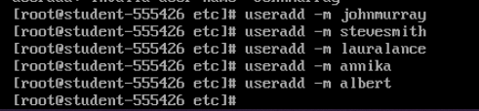

*Figure 12: Add Users*

# Configuring SSH & Public Key Authentication

SSH or Secure shell is a way of connecting to the system remotely from a different system. To use this the admin must install “openssh” which can be installed using “pacman -Sy openssh” to fetch the package and install it. This module can then be enabled and started using “systemctl enable sshd” and “systemctl start sshd” which will start the ssh daemon to allow connections. A user can now SSH into another users account, for example you could remotely access another VM as shown in figure 13 where the command “ssh [root@150.137.92.9](mailto:root@150.137.92.9)” is executed and the user is logged into the VM at address 150.137.92.9 as root after entering the user password.

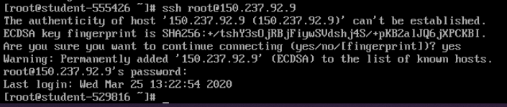

*Figure 13: SSH to another VM*

Once a connection has been established the user can use the system just like the current system, this is potentially very dangerous if someone was able to log on as root or as an admin. To check that root login is disabled you have to navigate to “etc/ssh/” and open the “sshd_config” file which has all of the settings for SSH connections. If “PermitRootLogin” is on make sure to turn it off to ensure roots security. This can be shown in Figure 14.

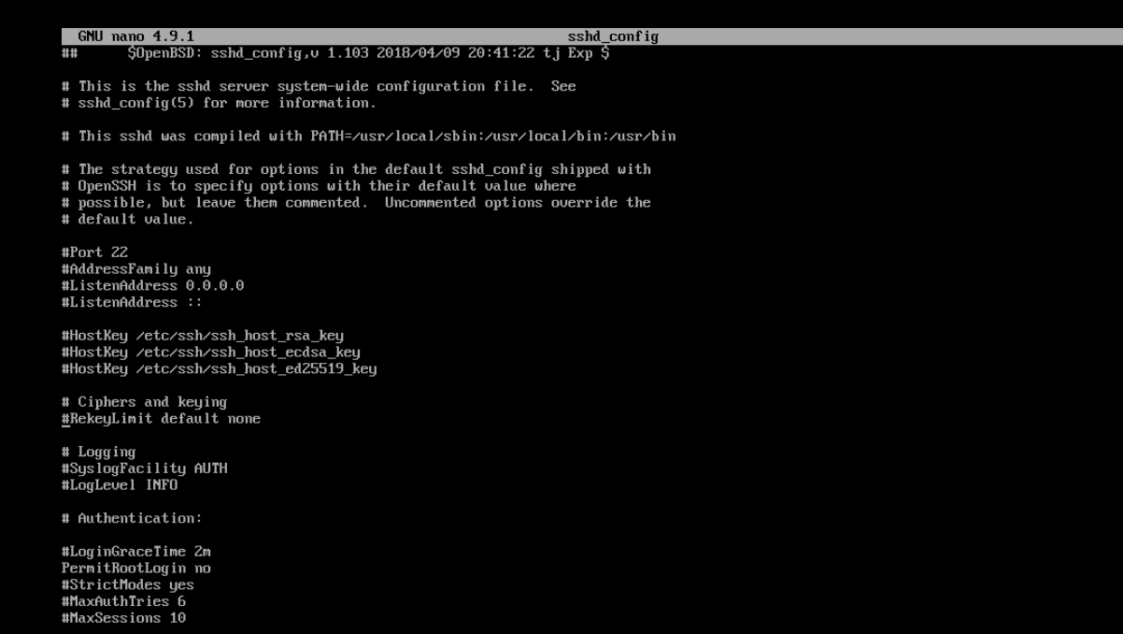

*Figure 14: sshd_config*

This file also has settings for public key authentication which works based on asymmetric encryption. Asymmetric encryption creates pair of keys, each person in the connection say Alice and Bob both have a public and private key. Both keys can encrypt, and both can decrypt their counterparts data. This is because both keys are mathematically linked to each other normally with use of large prime numbers. Asymmetric encryption works when both parties publish their public key on the internet so that they both can access those keys, say bob wants to send some data to Alice, bob will encrypt the data using Alice’s public key and send the data to Alice, because no malicious actor can decrypt this data without Alice’s private key this data is secure. When Alice receives the message, she can decrypt the message safely. In a Linux system the public key can be added to an authenticated keys file that will only allow connections from users that have a public key in this file, therefore authenticating this user. This public key authentication method also allows users to not be required to enter a password, therefore password authentication can be turned off when public key authentication is turned on. These modified settings can be shown in Figure 15.

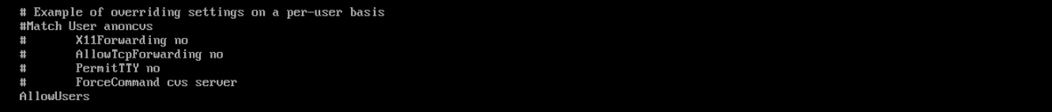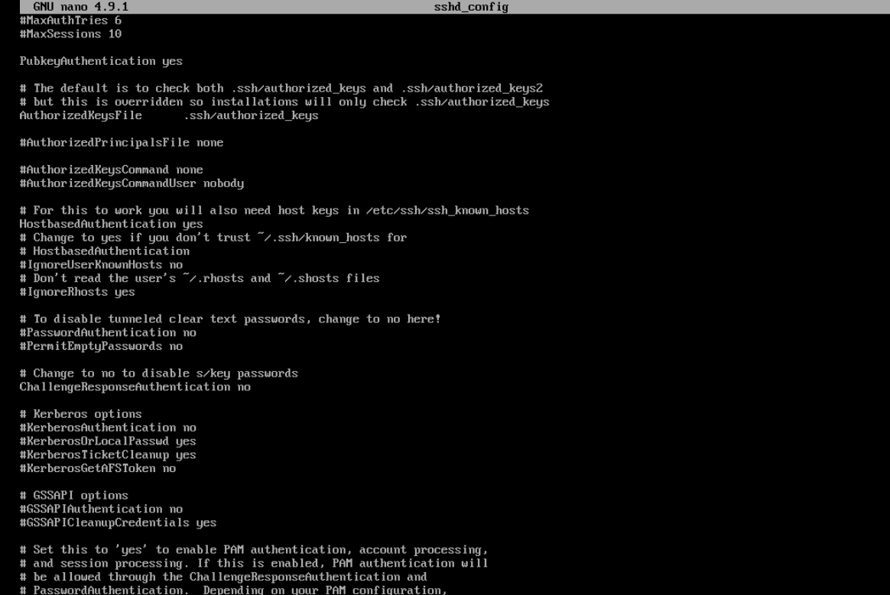

*Figure 15: Public Key Authentication Enabled*

Once changes to this file are made it is neccarsary to restart the SSHD service as it is currently running without the adjusted settings, this can be done by issuing the command “systemctl restart sshd”. To create a key pair for a user, say “duncan” the command “ssh-keygen” can be executed, this will create an RSA (Asymmetric Encryption Algorithm) Key pair in the users “.ssh” folder shown in figure 16, additionally, you can find “duncans” public key in figure 17. If you wanted to allow “duncan” to connect to your system you would add that key to your authorised keys file.

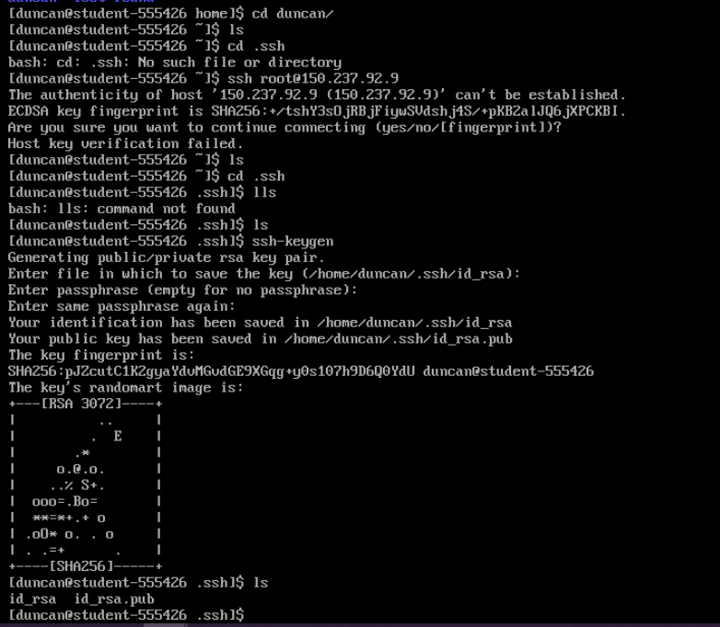

*Figure 16: Generating RSA Key Pair*

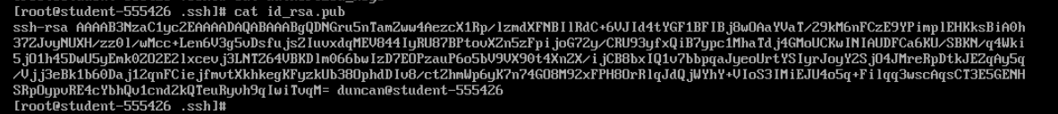

*Figure 17: “duncans” Public Key*

Supplied with the system specification there are public keys for each user that have been created on a separate system, if these keys are added to the “authorized_keys” file on each user then they could use public key authentication to remote ssh to their user account on this system. To do this the user must first load their public key on the system, for this “wget” was installed using “pacman -Sy wget” as “wget” will pull a file from a link and store it as a file which can be manipulated on the system. The public keys were then uploaded to a temporary file host (Station307, 2020) which gives a link to pull a file. The file being pulled using “wget” can be seen in figure 18.

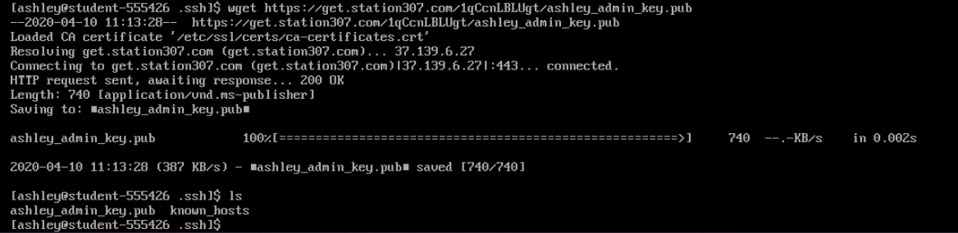

*Figure 18: Pulling Station307 link*

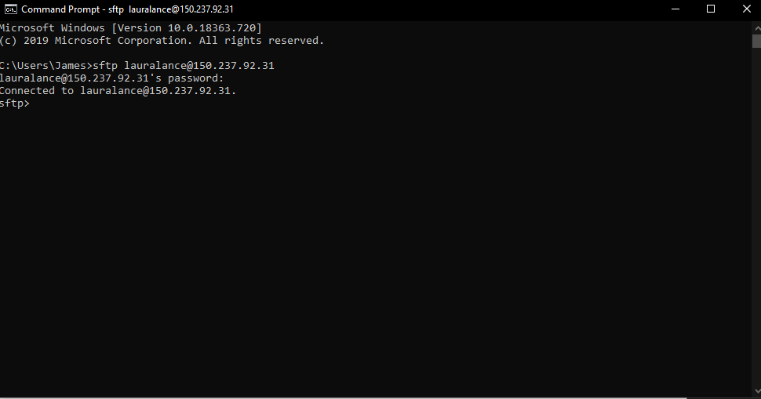Once all users keys are pulled from the temporary host the user can create an “authorized_keys” file by using “touch authorized_keys” and appending the key by issuing the command “cat Key >> authorized_keys”. This will add the key to the authorised keys file and allow connections using that key. Once all the keys are added each user can SSH into their own account and in the case of Laura lance she can access the http folder under “srv/http” by using the “sftp” command in windows or though a UI which she can install. This can be seen in Figure 19.

*Figure 19: SFTP Connection*

# Known Host Authentication

In the “sshd_config” file it is possible to enable known host authentication to allow albert to connect to his user area from a specific domain without having a public key. This can be enabled by turning on “HostbasedAuthentication”. Hosts can then be added to each users “known_hosts” files for what host they want, for each user this is located in the “.ssh” folder. Albert can add “albert-machine.net.dcs.ac.uk” to this list and he will be allowed access from the address without a public key.

# User Groups and Folder permissions

Each user is required to have access to different folders depending on their user, it is best to split down the users into what access they require. Both Annika and Albert are PHD Students that require access to a PHD folder managed by John Murray, for this reason adding them to a PHD user group would make sense as they both will have the same user permissions. Laura lances department is marketing and therefore only requires access to the http folder, she can be given a marketing group that allows here group access to the http folder and if any other marketing user needs access to this folder they can also be added. Steve is the only third year student on the system that requires a folder managed by John Murray, he can be given a group of his own for this as no other student or user is required to access this folder. John Murray on the other hand manages most of the students on this system, as he is a staff member he can be given a staff group although John may not use this group as much as the other users. These groups can be added and given to each user in the system using “groupadd <group>” and “usermod <username> -g <group>”, this can be shown in figure(s) 20.

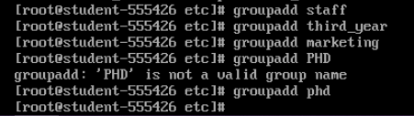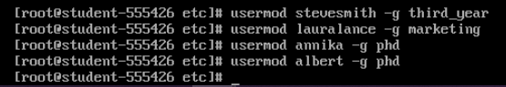

*Figure(s) 20: Creating and adding groups*

These folders can then be made by navigating to the “/srv” directory and issuing the command “mkdir <folder name>”. Permissions can then be set on these folders, Linux Permissions work by assigning Read, Write and Execute permissions to the Owner of the file, The group that the file is owned by and then everyone else. To give Laura special access to http her group can be granted Read Write and Execute permissions and the folder owner could be root or an admin with full permissions. Other users should not be able to access this folder so all permissions should be off. For Steve’s folder the folder owner should be John Murray as he is the main admin for the resources in the folder, Steve does not need to edit any files in the folder to his group can be given read and execute permissions, everyone else should not have permissions for this folder. Finally, the PHD folder should also be owned by John Murray as he is the main admin for resources here and requires full permissions, it is important that the users of PHD do not edit so the PHD group can be given read and execute permissions but not write permissions. These permissions are represented in the form of octal numbers and the break down to these numbers can be found in figure 21

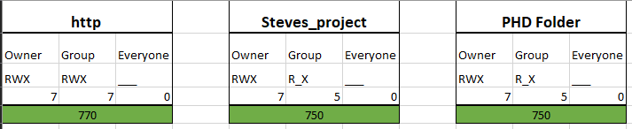

*Figure 21: Octal Representation*

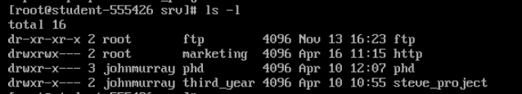These folder permissions can be set up by changing the folder owner using “chown <user> <folder>” changing the group owner using “chown :<group> <folder>”. Full permissions can then be changed by using “chmod <octal> <folder>” and permissions can be checked by running the command “ls -l” which will list the folder owners and permissions. An example of this can be found in figure 22.

*Figure 22: Folder Permssions*

These folder permissions fulfil all of the requirements for the system specification and you can find in the appendix tests to show how each user can access these folders. Additionally, it is worth noting that files can also be given these permissions so when the file owner creates a file they can ensure that permissions are set to make sure no user modifies the data. John may wish to use this for the PHD students and Steve.

# Uploading Research Material

John Murray has some research material to upload to the PHD users folder, this can be done in the same way that the public keys were uploaded using station307 (Station307, 2020) and “wget” however this only takes a singular file so John will have to send a zip file to the system. In order to unzip this “unzip” will have to be installed using “pacman -Sy unzip” this can then be used to unzip all of the files from the zip file sent through wget as shown in figure 23. Jahn may not wish to use this mode for all research so he could also use sftp much like Laura does for future uploads.

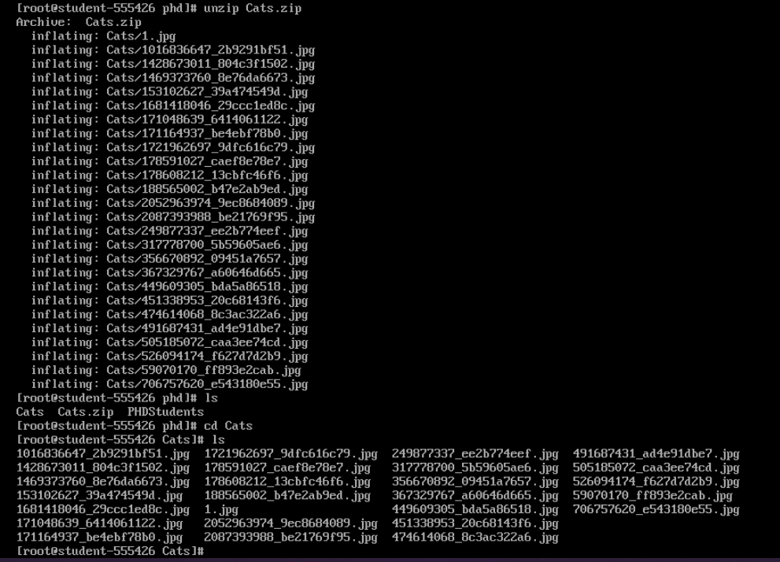

*Figure 23: Unzip*

# Critical Reflection & Conclusion

In conclusion setting up this system was quite fun, as finding different solutions to the problems I faced such as getting public keys onto the system challenged me to find an alternative way around using “wget” and Station307s temporary file hosting. There are some small things that I left unchanged for convenience however, I suggest these should be changed if the system was deployed. These were small things such as the “wheel” group not being required to enter a password for sudo, this is potentially very insecure if someone was able to access these account they could cause major damage to the system so should be password protected. It was also nice looking at how to build this system from the bottom up and build in good security practices.

# Bibliography

Hull University . (2020, Febuary 11). *Hull Univeristy Password Policy*. Retrieved from Hull University : https://www.hull.ac.uk/editor-assets/docs/password-policy.pdf

Random Keygen. (n.d.). *Random Keygen*. Retrieved from Random Keygen: https://randomkeygen.com/

Station307. (2020). *Station307*. Retrieved from Station307: https://www.station307.com/#/

# Appendix

## Annika Tests

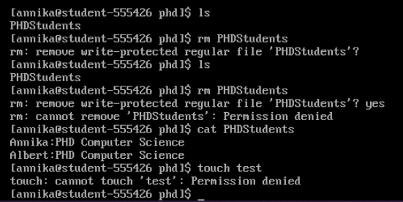

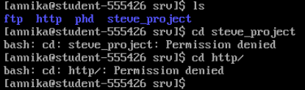

## Steve Tests

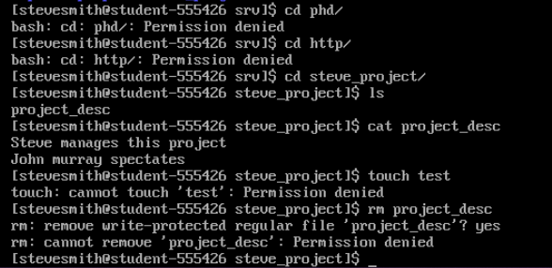

## Laura Lance Tests

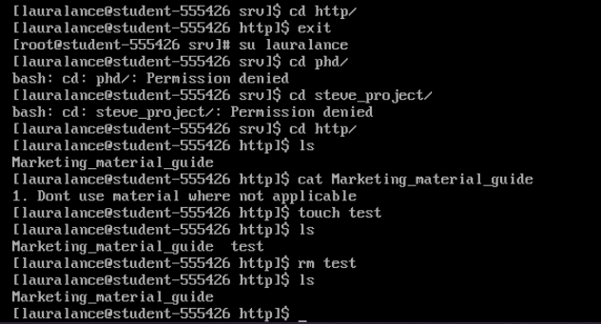

## John Tests

